USA CUSTOMER S/4 HANA TESTING FOR USA

YSHP Ship to party Exelan
YSHP do not have company code data it only have sale data and general data hence recon account will not be available.

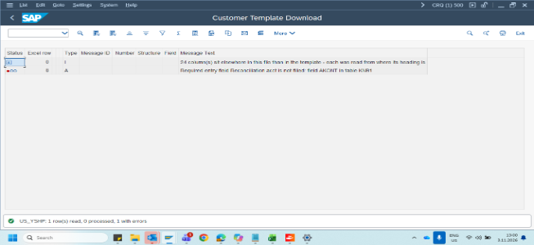

YVMI Indirect customer_ Exelan

Even though recon account value is correct the program is not reading that data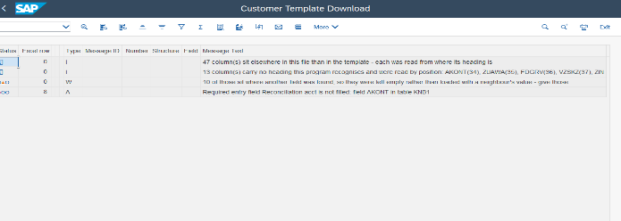
YVSP Sold to party Exelan

lock box is not there in template and shipping point is blank



